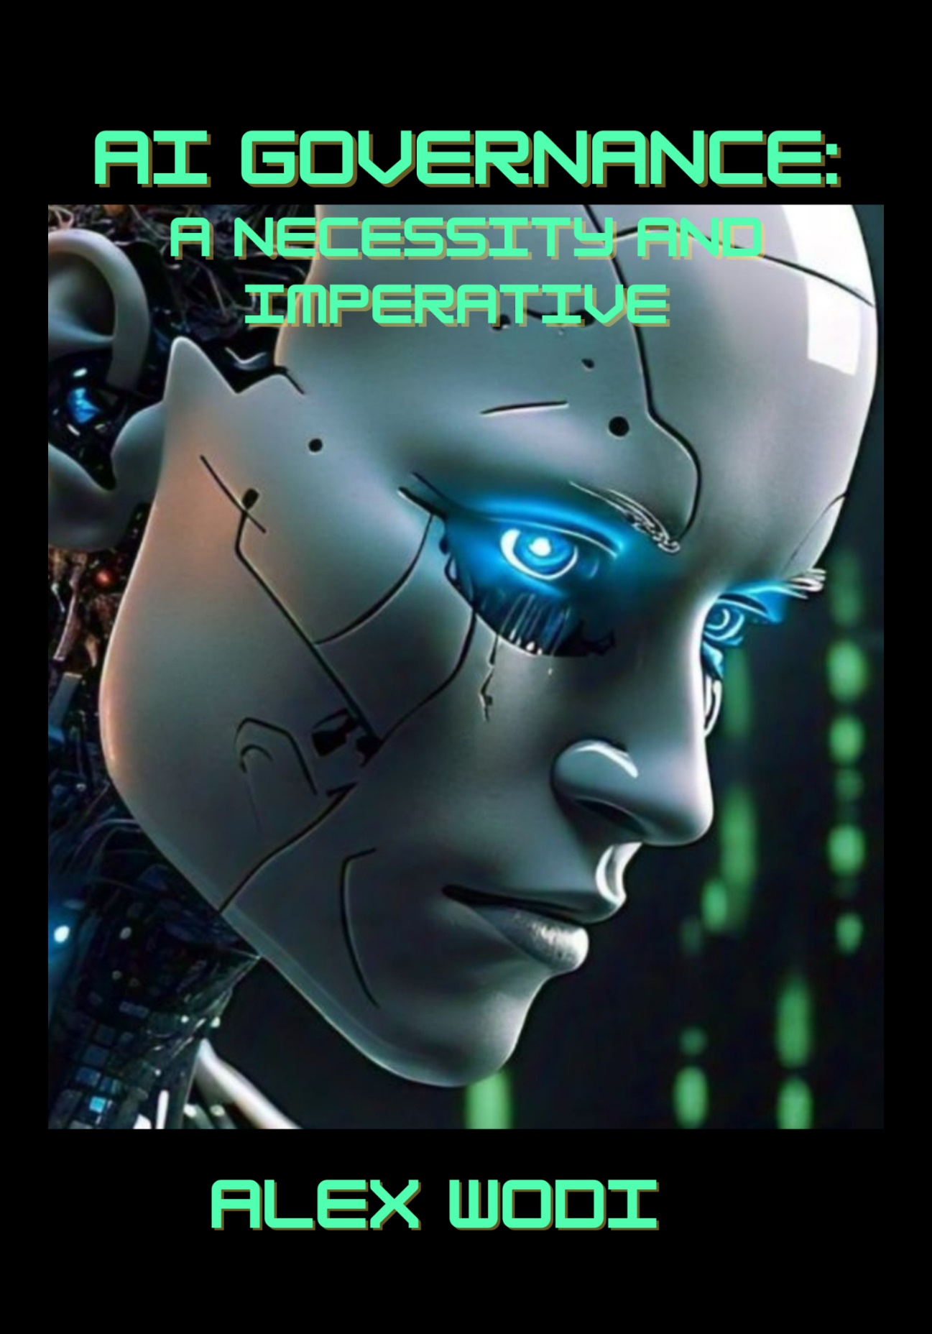

AI GOVERNANCE:
A NECESSITY AND IMPERATIVE
AI Governance:
A NECESSITY AND IMPERATIVE

June 10, 2025
Alex wodi

Contents

Acknowledgement xvii
Preface xix
CHAPTER ONE 1
Artificial Intelligence: Provenance and Governance 1
1.0 AI and AI Governance 1
1.1 AI and AI Systems: History, Types and Applications 5
1.1.1 (a) AI in Antiquity 8
Greek Gods, Heroes and Automatons 9
Devas and Automata in Asian Legends 11
The Legacy of Ptah and the Alexandrian Engineers 14
1.1.1 (b) Arabian Automata and Innovation 24
1.1.1 (c) Automatons in China 26
1.1.1 (d) Renaissance Men and Clockmakers 28
1.1.1 (e) Automatons in the Age of Reason 31
1.1.2 AI and Robotic Servitude 41
1.1.3 The Dartmouth AI Workshop and the Turing Test 42
1.1.4 So, what exactly is artificial intelligence? 50
Generative AI 55
Predictive AI 57
Machine Learning (ML) 58
Supervised learning 59
Unsupervised learning 60
Reinforcement learning 61
Deep Learning 61
Narrow AI (or Weak AI 63
General AI (or Strong AI) 64
Super AI or Artificial Super Intelligence (ASI) 64
Artificial General Intelligence (AGI) 65
1.2. What is AI Governance? 76
1.3 Why is AI Governance So Important? 79
AI and Education Technologies (EdTech) 83
AI and the Three Laws of Robotics 95
AI Safety and AI Ethics 99
A Global Approach to AI Governance 105
AI, the Environment and Human Rights 113
Algorithm Bias and Discrimination 125
AI and Copyright 141
AI Solutions and Dating Sites 143
AI and the ELIZA Effect 144
AI and Cyberattacks 151
Malicious AI and the Dark Web 154
Framing Strategies for AI Governance 156
CHAPTER TWO 158
The OECD AI Principles 158
2.1 OECD AI Principles 158
Background to the OECD AI Principles 159
Scope of Recommendations 161
OECD AI Policy Observatory 165
The OECD and GPAI 171
2.2 UNESCO Recommendation on the Ethics of AI 172
CHAPTER THREE 178
The NIST AI Risk Management Framework 178
3.1 NIST AI RMF 178
A Framework for Managing AI Risk 179
Framing Risk 181
Audience 184
Trustworthy AI 184
Effectiveness of the AI RMF 187
Core 187
Profiles 191
AI RMF Playbook and Other Key Developments 192
Operationalizing the NIST AI RMF 194
3.2 ISO 42001 - AI Management System Standard 195
CHAPTER FOUR 200
The EU Artificial Intelligence Act 200
4.0 EU AI Act 200
4.1 Highlights and Essential Provisions of the EU AI Act. 202
A. Subject matter and Scope 202
B. Definitions 203
C. Risk-Based Approach 207
D. Exemptions to Scope of the AI Act 216
E. Penalties 217
F. Timelines 219
G. Governance Architecture 220
H. Reporting Serious Incidents 223
4.2 We have a Law: Now What? 225
CHAPTER FIVE 237
Global Trends and Developments 237
5.0 Global AI Strategies 237
5.1 UNITED STATES (US) 237
US’s AI Readiness Index 238
Blueprint for AI Bill of Rights 240
Voluntary Commitments by AI companies 241
Executive Orders 241
US State Laws 242
FTC Guidelines and Enforcement Action 249
AI lawsuits in the US Courts 250
US Companies take lead in AI development 252
Second Term Re-Adjustments and Re-Alignment 253
5.2 UNITED KINGDOM (UK) 258
UK’s National AI Strategy 259
UK AI Safety Summit – Bletchley 261
AI Readiness Rating 261
The EU AI Act and UK AI Actors 263
AI Lawsuits in UK 263
5.3 CANADA 264
AI Readiness Ranking 265
Canada’s AI Strategy 266
Canada’s AI governance approach 267
5.4 CHINA 271
AI Readiness Ranking 272
China’s National AI Committee 273
Ethical Norms, Measures and Administrative Provisions 277
AI Lawsuits 280
Much Ado About AI Models and Paradigm Shifts 282
5.5 INDIA 287
India’s AI Strategy and Infrastructure 287
Global AI Ranking 291
5.6 JAPAN 292
Japan’s AI Strategy 294
Japan’s Position on AI and Copyright 294
AI Readiness Index 295
5.7 SINGAPORE 297
AI Readiness Index 298
AI Governance Framework 299
5.8 EGYPT 308
Egypt’s AI Strategy 308
Capacity Building Initiatives 311
AI Readiness Index 314
5.9 KENYA 315
AI Strategy 315
AI Readiness Index 319
5.10 NIGERIA 320
AI Workshop of 120 Experts 321
National AI Strategy 323
The National Digital Economy Policy and Strategy 324
Regulating AI and Privacy 326
Nigeria’s AI Readiness Index 326
5.11 SOUTH AFRICA 328
South Africa’s AI Strategy 328
AI Readiness Index 332
5.12 UNITED ARAB EMIRATE (UAE) 334
AI Strategy 334
AI Readiness Index 340
5.13 SAUDI ARABIA 341
Data and AI Strategy 341
AI Readiness Index 344
5.14 CHILE 349
AI Strategy and Policy 349
AI Readiness Index 351
5.15 BRAZIL 352
Brazil’s AI Strategy - EBIA 353
AI Bill 2338/2023 355
AI Readiness Index 357
5.16 COLOMBIA 357
Colombia’s AI Strategy and Framework 358
Emerging Legislation 365
Global AI Rating 366
5.17 AUSTRALIA 368
AI Ethics Principles and Safety Standards 368
AI Readiness Index 374
5.18 NEW ZEALAND 375
AI Strategy 376
Global AI Index 384
AI Challenges and Emerging Trends 387
1.The Black box Problem 392
2. Data Problem 398
3. AI Hallucinations - 404
4. AI and Law Practice 409
5. AI literacy 415
6. AI Red Teaming 421
7. Agentic AI 422
8. AI, CSR and ESG 426
9. AI and Healthcare 438
10. The TESCREAL Bundle 460
CHAPTER SIX 471
Next Steps 471
6.0 Next Steps for AI Readiness 471
6.1 Getting Your Organization AI ready 473
1. Understanding AI 473
2. AI Strategy 474
3. AI Risk Assessment and Management 474
4. Human Capital Management 478
Further Reading & Resources 484
About Author 494
Annexes 496
Annex I 496
The New Legislative Framework – List of Laws 496
Annex II 498
AI Glossary 498

Preface
The explosion of interest in Artificial Intelligence (AI) which bestrode the introduction of OpenAI’s Chat GPT and GPT 4 underscores the need for this book, to contextualize and address public concerns about AI’s potential benefits and risks to humans and society. The book builds on a paper I wrote on AI governance (in 2024) by examining in more detail the laws, policies, frameworks, standards, and issues raised.
If you are like me or most people, my early impression of AI was largely influenced and shaped by Hollywood. I remember the doomsday scenario in the Terminator movie franchise. However, there is more to AI than killer robots or drones. AI has huge potential in such areas as agriculture, education, finance, healthcare, manufacturing, robotics, legal practice, transportation, law enforcement, defence and military applications.
AI like many human technologies and discoveries has a dual use problem. Meaning it may be employed for good or bad. It is often the latter that is reflected in movies. The rapid evolution of AI technology at breakneck speed has implications for humans and society. Algorithm bias and discrimination, fear of jobs displacement, systemic and environmental risks, the intersections between AI and data privacy, and copyright violations have made AI governance not just a necessity but also imperative.
This work delves into the history and use cases of AI from automatons like Talos the bronze giant killer-robot in Greek mythology and the spirit-powered mechanical warriors said to guard Buddha’s stupa, to the self-animated inventions of the Alexandrian Engineers during the Hellenistic period, and the ingenious devices of the Banu Musa brothers and Al-Jazari from the Islamic Golden Age, to Leonardo da Vinci’s robotic knight and de Vaucanson’s digesting duck during the Renaissance and Age of Reason, to Turing’s WWII code breaking machines and Weizenbaum’s ELIZA in the 1960s. It also looks at global and regional efforts to come up with strategies and regulatory frameworks for AI governance. Chief amongst them include: the OECD AI Principles; UNESCO Recommendation on the Ethics of AI; NIST AI RMF; ISO 42001; and the EU AI Act. The common thread among these frameworks and legislation is identifying and categorizing AI developments and deployments according to their risk levels and providing guidelines for ethical and trustworthy AI with considerations for human safety and innovation. Also identified and examined are some national efforts, namely in the US, UK, Canada, China, India, Japan, Singapore, Brazil, Chile, Colombia, Egypt, Kenya, Nigeria, South Africa, Saudi Arabia, UAE, Australia, and New Zealand. We analysed and compared their ranking on the Tortoise Media Global AI Index and Oxford Insights’ AI Readiness Index, as well as the relevant AI strategies, policies and laws in the various countries.
We also examined AI challenges and emerging trends, like – Agentic AI, AI Hallucination, Black box problem, AI and Data, AI in Healthcare, AI and Law Practice, AI and ESG, AI Literacy, AI Red Teaming, and TESCREALism.
Finally, we gave organizations useful tips for getting AI ready by setting up an AI strategy and AI governance framework.
The overall objective of the book is to enhance understanding of AI governance among stakeholders, including policymakers and consumers, and to equip AI actors with the tools to establish a robust AI governance regime. This will promote the development and deployment of innovative and trustworthy AI solutions with positive outcomes for humans and society.
Alexander A Wodi
10 June 2025

It took ChatGPT two months to reach 100 million users. As at May 2025, it had close to 800 million weekly active users and around 122.58 million daily users. Shubham Singh “ChatGPT Statistics 2025 – DAU &MAU Data (Worldwide)” (Demand Sage, 19 May 2025). <https://www.demandsage.com/chatgpt-statistics/> accessed 23 May 2025. See also Statista, Forbes and Reuters.
Similar narratives are presented in such movies as War Games (1983); The Matrix (1999); I, Robot (2004) and more recently, The Creator (2023) and Atlas (2024).
Examples include: - guns and gunpowder, nuclear energy, the atom bomb, chemical and biotech, and the internet and social media.
Movies are replete with examples of mad scientists or terrorist groups weaponizing tech for evil purposes.

